**Abdykamat Adilet lab5 . DATABASES**

**1. Add a CHECK constraint to passenger table to provide that passengers must be at least 10 years old.**

ALTER TABLE passenger

ADD CONSTRAINT check_age

CHECK (EXTRACT(YEAR FROM AGE(date_of_birth)) >= 10);

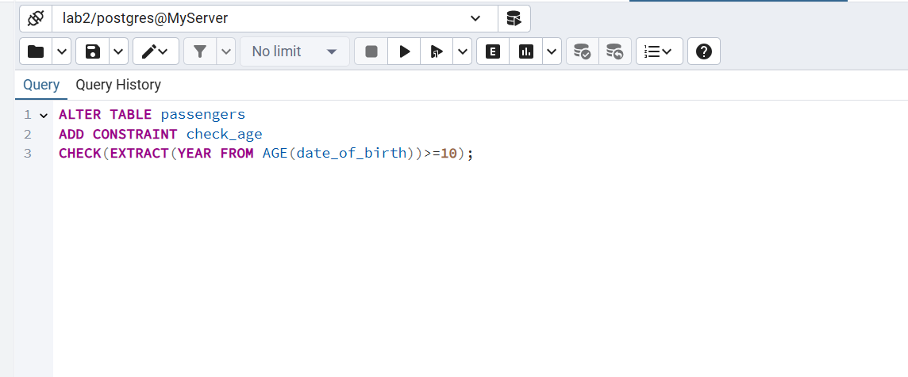

**2. Add a CHECK constraint to accept values in booking price not more than 50000tg and less than 0tg.**

ALTER TABLE booking

ADD CONSTRAINT checking_booking_price

CHECK(ticket_price >= 0 and ticket_price <=50000);

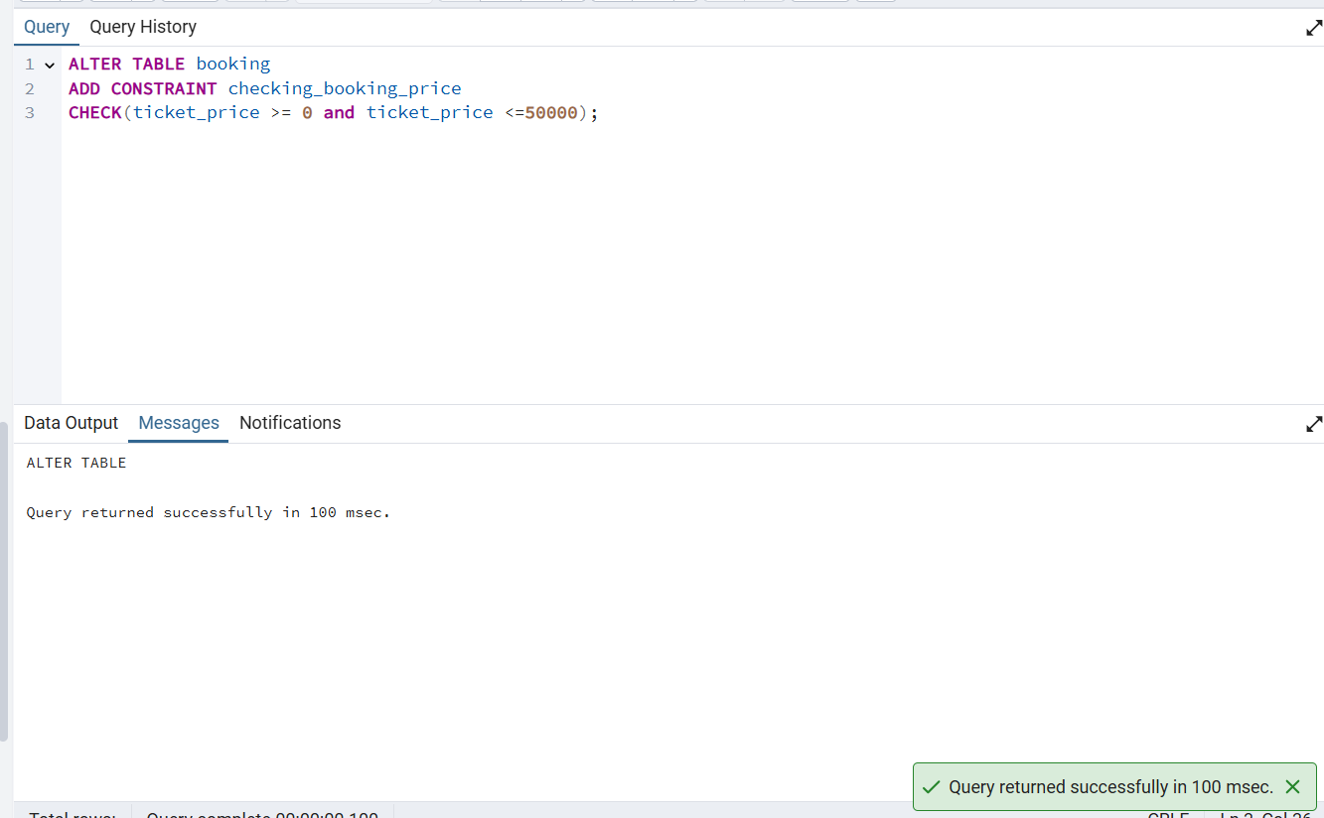

**3. Add a CHECK constraint to accept the luggage weight between 1 and 23 kg.**

ALTER TABLE baggage

ADD CONSTRAINT check_weight

CHECK (weight_in_kg BETWEEN 1 AND 23);

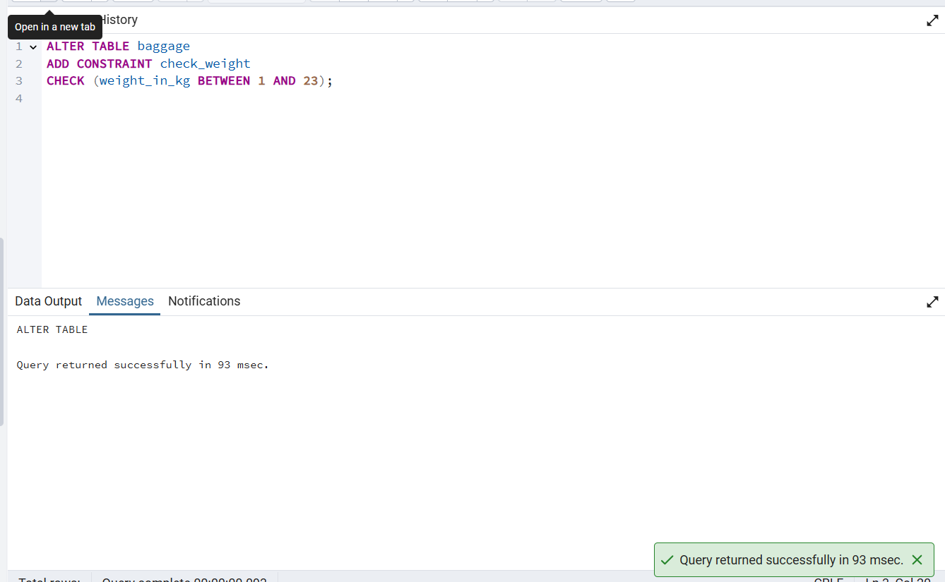

**4. Add a CHECK constraint to ensure that all values in airport_name must have at least 10 characters.**

ALTER TABLE airport

ADD CONSTRAINT check_length

CHECK (CHAR_LENGTH(airport_name) >= 10);

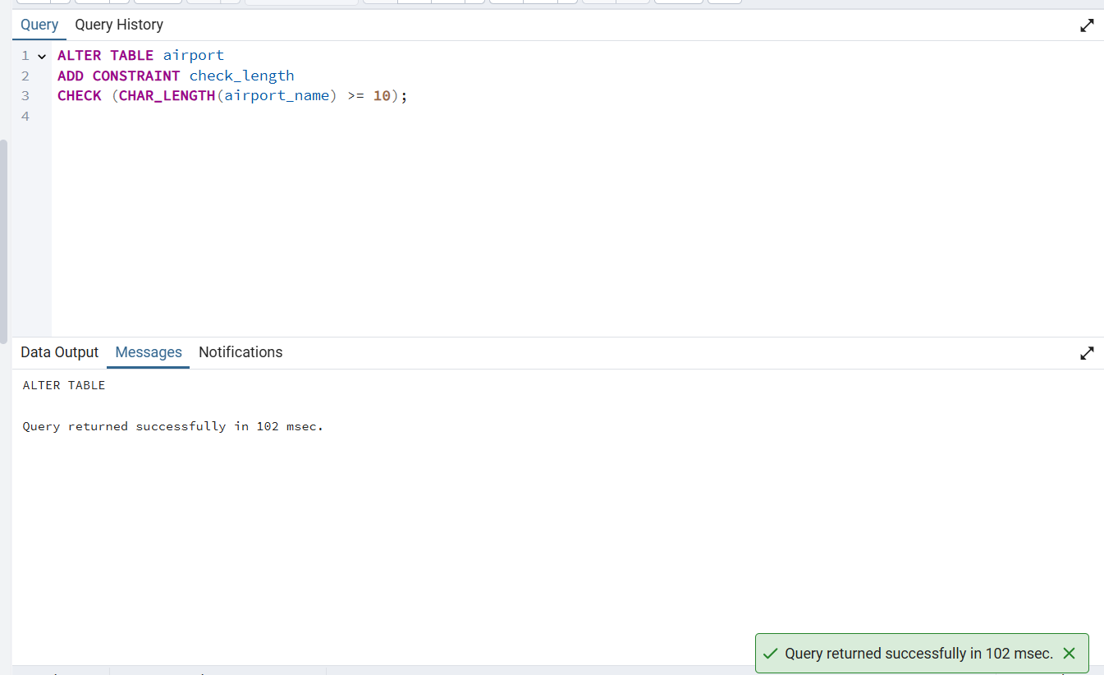

**5. Add UNIQUE constraint to some columns in each table in database.**

ALTER TABLE passengers

ADD CONSTRAINT unique_passport

UNIQUE (passport_number);

ALTER TABLE airport

ADD CONSTRAINT unique_airport_id

UNIQUE (airport_id);

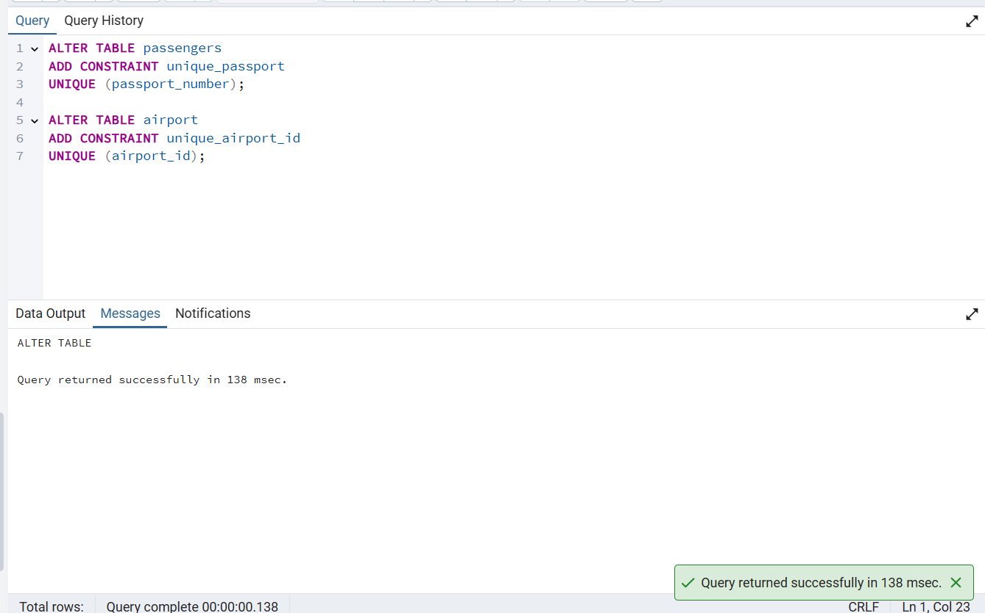

**6. Add a CHECK constraint to ensure that male passengers must be at least 18 years old and female passengers must be 19 years old.**

ALTER TABLE passengers

ADD CONSTRAINT check_gender_age

CHECK (

(gender = 'M' AND EXTRACT(YEAR FROM AGE(date_of_birth)) >= 18)

OR

(gender = 'F' AND EXTRACT(YEAR FROM AGE(date_of_birth)) >= 19)

);

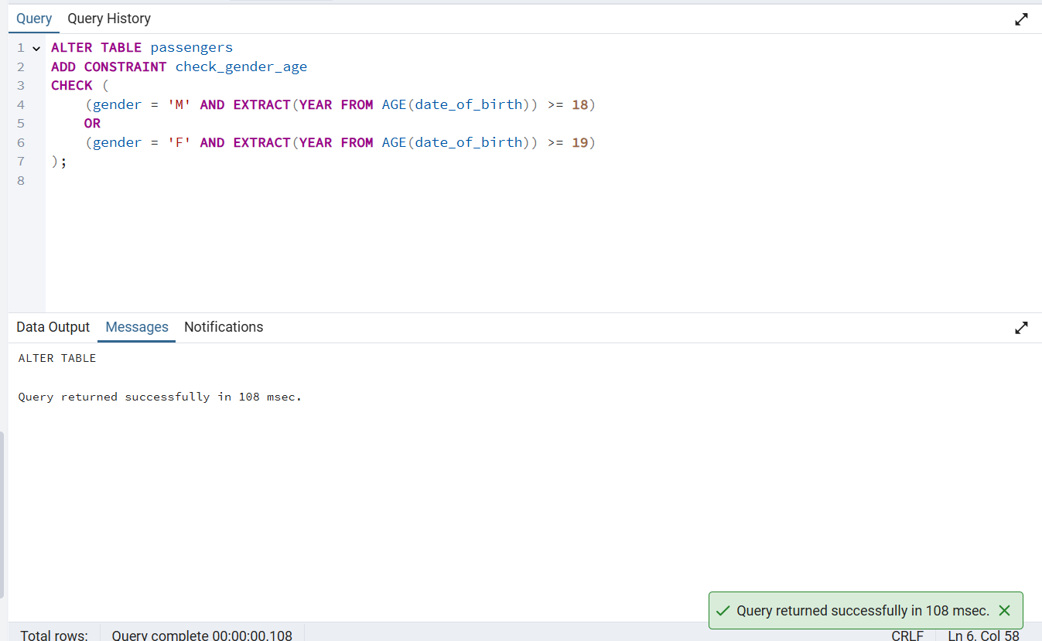

**7. Add a CHECK constraint to add rule as follow (use column country_of_citizenship):**

**· Passengers from Kazakhstan must be at least 18 years old.**

**· Passengers from France must be at least 17 years old.**

**· Passengers from other countries must be at least 19 years old.**

ALTER TABLE passengers

ADD CONSTRAINT check_age_by_country

CHECK (

(country_of_citizenship = 'Kazakhstan' AND EXTRACT(YEAR FROM AGE(date_of_birth)) >= 18)

OR

(country_of_citizenship = 'France' AND EXTRACT(YEAR FROM AGE(date_of_birth)) >= 17)

OR

(country_of_citizenship NOT IN ('Kazakhstan', 'France') AND EXTRACT(YEAR FROM AGE(date_of_birth)) >= 19));

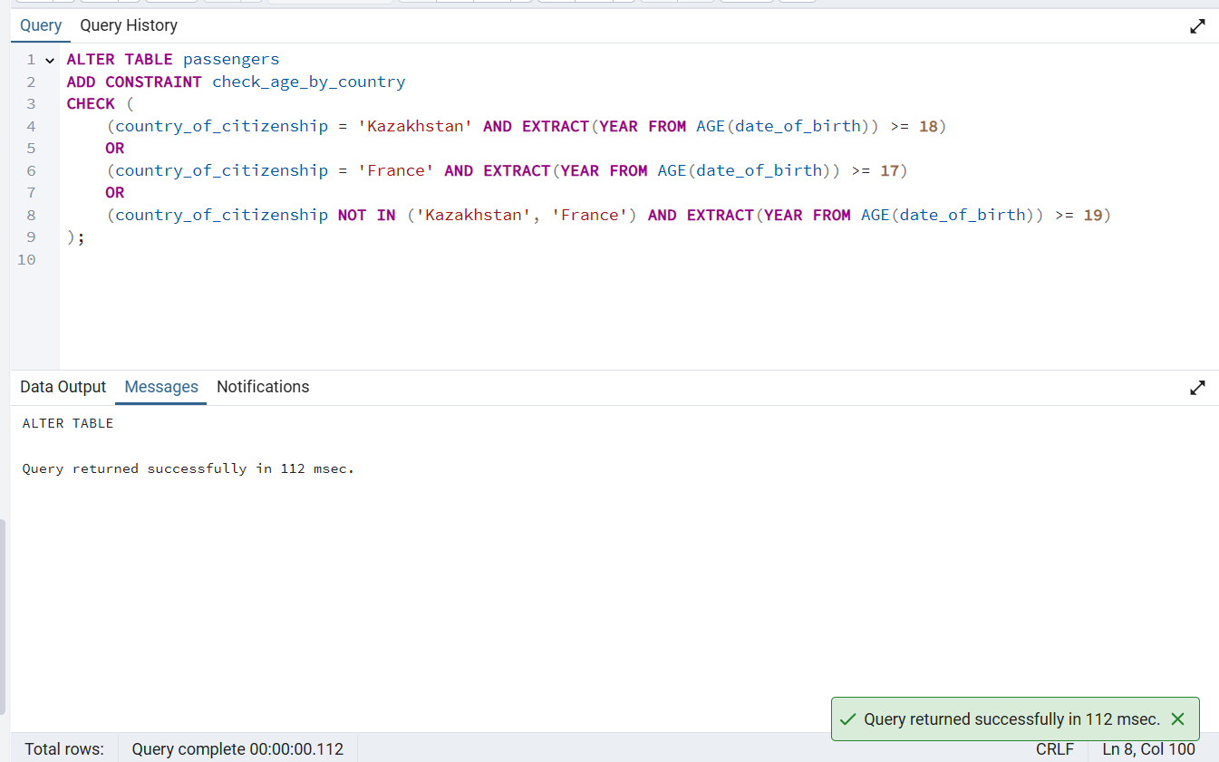

**8. Add a ticket_discount column to table booking and a CHECK constraint to apply some discount based on ticket price and created time:**

**· the constraint applies a 5% discount for tickets created after 2024-01-01,**

**and 10% discount for tickets created before 2024-01-01.**

ALTER TABLE booking

ADD COLUMN ticket_discount numeric;

ALTER TABLE booking

ADD CONSTRAINT check_ticket_discount

CHECK (

(created_at >= '2024-01-01' AND ticket_discount = ticket_price * 0.05)

OR

(created_at < '2024-01-01' AND ticket_discount = ticket_price * 0.10)

);

